Github link: https://github.com/manashb96/Test_Acvi

Assignment 1: Labels

Solution: Template matching

**Non-symmetrical dot detection**

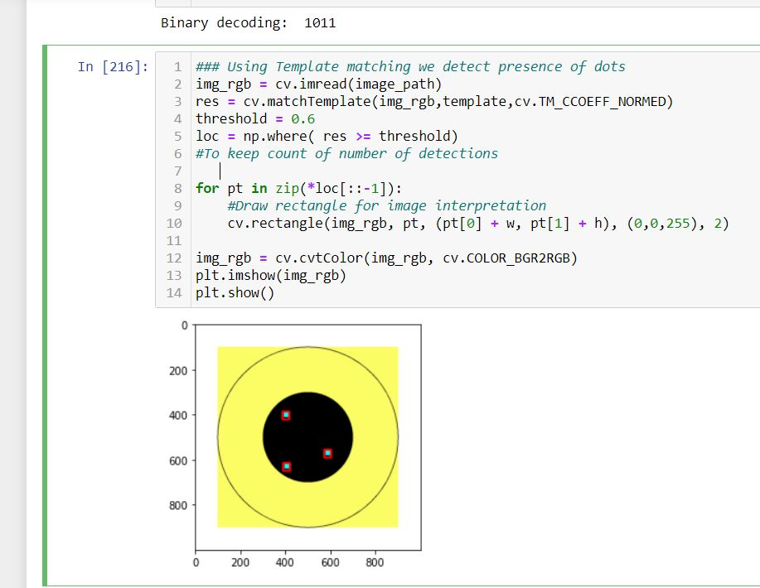

**Symmetrical dot detection**

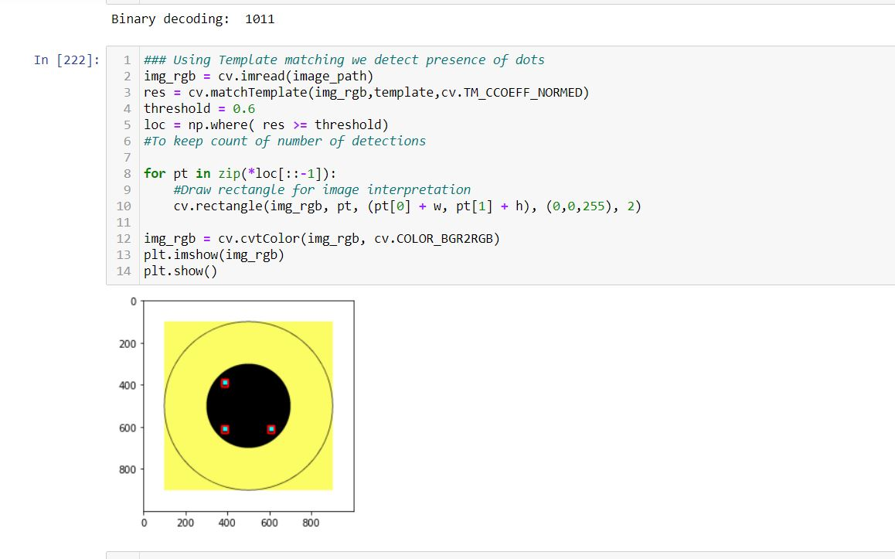

Assignment 2: Clustering

Solution: Plotly.express

**3D plotting of training dataset along with hovering tooltips**

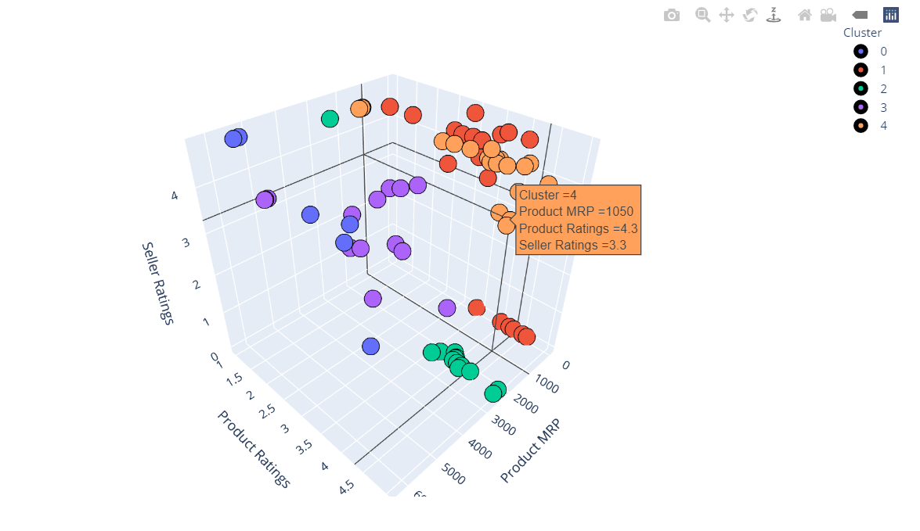

**3D plotting of testing dataset along with hovering tooltips**

